Machine Description | DC-1 is a beginner-level VulnHub machine that demonstrates exploitation of a vulnerable Drupal 7 web application. By leveraging known vulnerabilities, an attacker can gain remote code execution and escalate privileges to obtain root access.
Target IP | 192.168.0.119
Vulnerability Name | Drupal Core SQL Injection (Drupalgeddon) – CVE-2014-3704
Port and Service | TCP 80 – HTTP (Apache Web Server)
Severity and Score | 9.8 Critical
Attack Vector | CVSS:3.1/AV:N/AC:L/PR:N/UI:N/S:U/C:H/I:H/A:H
Proof of Concept | STEP 1: Discover the Target IP using netdiscover .  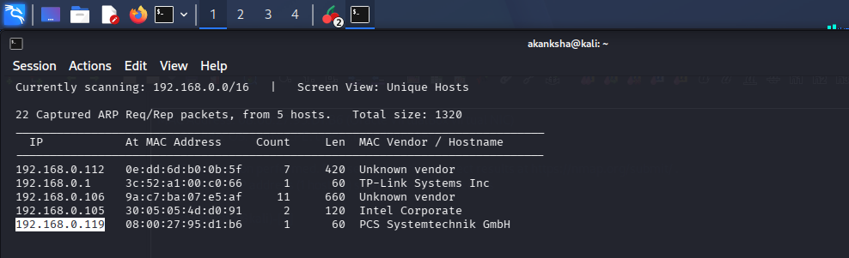  STEP 2: Scan for Open ports using nmap.  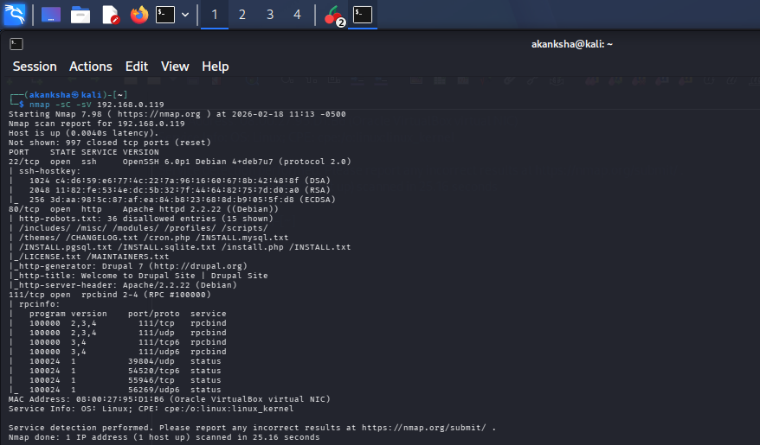  Here we can see that site is running CMS of Drupal on 80  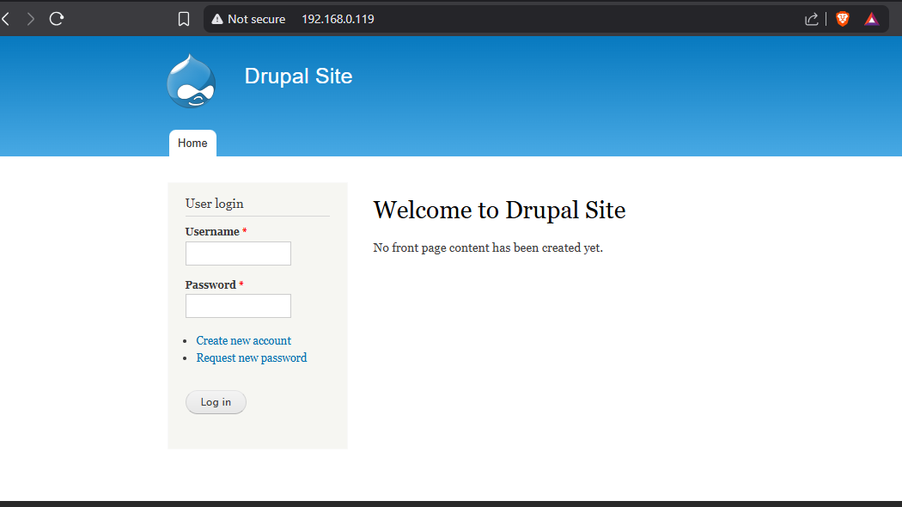  Let’s find If we can find any exploit related to it on Searchsploit  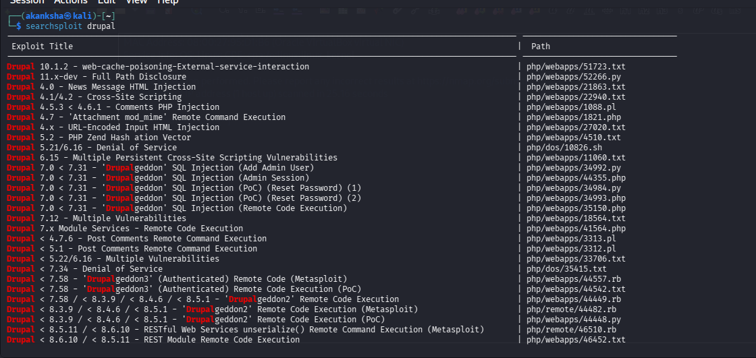  STEP 3: So there are some exploits so let’s use Metasploit.  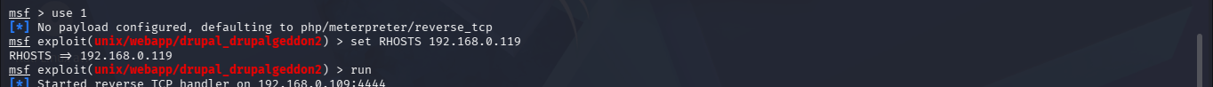  We got access as www-data user  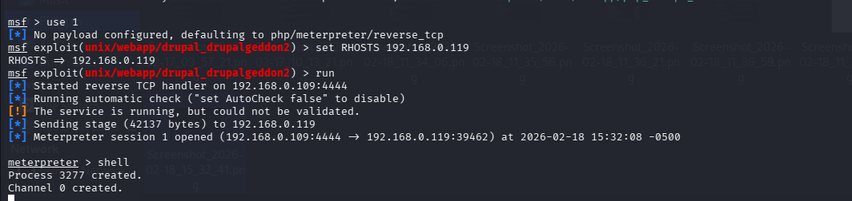  STEP 4: Let’s try to escalate privileges.  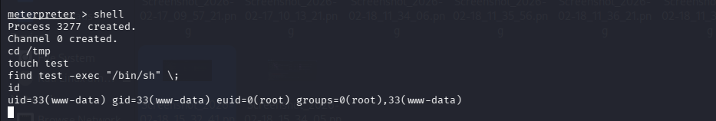  Here we can see we got the root
Impact | - Allows attackers to execute arbitrary commands on the server (Remote Code Execution).  - Complete compromise of the web application and underlying system.  - Exposure of sensitive data such as configuration files, user credentials, and database information.  - Privilege escalation may lead to full root access.  - Attackers can install backdoors and maintain persistent access to the system.
Remediations | - Update Drupal to the latest secure version to patch the vulnerability.  - Apply official security patches released by the Drupal security team.  - Restrict unnecessary services and close unused ports.  - Implement a Web Application Firewall (WAF) to block exploitation attempts.  - Regularly monitor logs and conduct security testing to detect vulnerabilities early.
Reference | https://unit42.paloaltonetworks.com/unit42-exploit-wild-drupalgeddon2-analysis-cve-2018-7600/

